Voyager 2

**From Wikipedia, the free encyclopedia**

https://en.wikipedia.org/wiki/Voyager%202  
Licensed under CC BY-SA 3.0:  
https://en.wikipedia.org/wiki/Wikipedia:Text_of_Creative_Commons_Attribution-ShareAlike_3.0_Unported_License

# Voyager 2

* *Voyager 2 is now in its extended mission to study the outer reaches of the Solar System and has been operating for 41 years, 9 months and 18 days as of 7 June 2019.*
* *Voyager 2 is a space probe launched by NASA on August 20, 1977, to study the outer planets.*
* *Part of the Voyager program, it was launched 16 days before its twin, Voyager 1, on a trajectory that took longer to reach Jupiter and Saturn but enabled further encounters with Uranus and Neptune.*

Voyager 2 is a space probe launched by NASA on August 20, 1977, to study the outer planets. Part of the Voyager program, it was launched 16 days before its twin, Voyager 1, on a trajectory that took longer to reach Jupiter and Saturn but enabled further encounters with Uranus and Neptune. It is the only spacecraft to have visited either of these two ice giant planets.

Its primary mission ended with the exploration of the Neptunian system on October 2, 1989, after having visited the Uranian system in 1986, the Saturnian system in 1981, and the Jovian system in 1979. Voyager 2 is now in its extended mission to study the outer reaches of the Solar System and has been operating for 41 years, 9 months and 18 days as of 7 June 2019. It remains in contact through the NASA Deep Space Network.

At a distance of 120 AU (1.80×1010 km) (about 16.4 light-hours) from the Sun as of February 25, 2019, moving at a velocity of 15.341 km/s (55,230 km/h) relative to the Sun, Voyager 2 is the fourth of five spacecraft to achieve the escape velocity that will allow them to leave the Solar System. The probe left the heliosphere for interstellar space on November 5, 2018, becoming the second artificial object to do so, and has begun to provide the first direct measurements of the density and temperature of the interstellar plasma.

# History

# Background

* *Upon successful completion of Voyager 1's objectives, Voyager 2 would get a mission extension to send the probe on towards Uranus and Neptune.*
* *Voyager 2 was also to explore Jupiter and Saturn, but on a trajectory that would have the option of continuing on to Uranus and Neptune, or being redirected to Titan as a backup for Voyager 1.*

In the early space age, it was realized that a periodic alignment of the outer planets would occur in the late 1970s and enable a single probe to visit Jupiter, Saturn, Uranus, and Neptune by taking advantage of the then-new technique of gravity assists. NASA began work on a Grand Tour, which evolved into a massive project involving two groups of two probes each, with one group visiting Jupiter, Saturn, and Pluto and the other Jupiter, Uranus, and Neptune. The spacecraft would be designed with redundant systems to ensure survival through the entire tour. By 1972 the mission was scaled back and replaced with two Mariner-derived spacecraft, the Mariner Jupiter-Saturn probes. To keep apparent lifetime program costs low, the mission would include only flybys of Jupiter and Saturn, but keep the Grand Tour option open.:263 As the program progressed, the name was changed to Voyager.

The primary mission of Voyager 1 was to explore Jupiter, Saturn, and Saturn's moon, Titan. Voyager 2 was also to explore Jupiter and Saturn, but on a trajectory that would have the option of continuing on to Uranus and Neptune, or being redirected to Titan as a backup for Voyager 1. Upon successful completion of Voyager 1's objectives, Voyager 2 would get a mission extension to send the probe on towards Uranus and Neptune.

# Spacecraft design

* *Constructed by the Jet Propulsion Laboratory (JPL), Voyager 2 included 16 hydrazine thrusters, three-axis stabilization, gyroscopes and celestial referencing instruments (Sun sensor/Canopus Star Tracker) to maintain pointing of the high-gain antenna toward Earth.*
* *The spacecraft also included 11 scientific instruments to study celestial objects as it traveled through space.*

Constructed by the Jet Propulsion Laboratory (JPL), Voyager 2 included 16 hydrazine thrusters, three-axis stabilization, gyroscopes and celestial referencing instruments (Sun sensor/Canopus Star Tracker) to maintain pointing of the high-gain antenna toward Earth. Collectively these instruments are part of the Attitude and Articulation Control Subsystem (AACS) along with redundant units of most instruments and 8 backup thrusters. The spacecraft also included 11 scientific instruments to study celestial objects as it traveled through space.

# Communications

* *Built with the intent for eventual interstellar travel, Voyager 2 included a large, 3.7 m (12 ft) parabolic, high-gain antenna (see diagram) to transceive data via the Deep Space Network on the Earth.*

Built with the intent for eventual interstellar travel, Voyager 2 included a large, 3.7 m (12 ft) parabolic, high-gain antenna (see diagram) to transceive data via the Deep Space Network on the Earth. Communications are conducted over the S-band (about 13 cm wavelength) and X-band (about 3.6 cm wavelength) providing data rates as high as 115.2 kilobits per second at the distance of Jupiter, and then ever-decreasing as the distance increased, because of the inverse-square law. When the spacecraft is unable to communicate with Earth, the Digital Tape Recorder (DTR) can record about 64 kilobytes of data for transmission at another time.

# Power

* *Voyager 2 is equipped with 3 Multihundred-Watt radioisotope thermoelectric generators (MHW RTG).*

Voyager 2 is equipped with 3 Multihundred-Watt radioisotope thermoelectric generators (MHW RTG). Each RTG includes 24 pressed plutonium oxide spheres, and provided enough heat to generate approximately 157 W of electrical power at launch. Collectively, the RTGs supplied the spacecraft with 470 watts at launch (halving every 87.7 years), and will allow operations to continue until at least 2020.

RTG inner heat source

RTG assembly

RTG unit

# Attitude control and propulsion

* *Because of the energy required to achieve a Jupiter trajectory boost with an 1,819-pound (825 kg) payload, the spacecraft included a propulsion module made of a 2,476-pound (1,125 kg) solid-rocket motor and eight hydrazine monopropellant rocket engines, four providing pitch and yaw attitude control, and four for roll control.*
* *Sixteen hydrazine MR-103 thrusters on the mission module provide attitude control.*
* *The propulsion module was jettisoned shortly after the successful Jupiter burn.*

Because of the energy required to achieve a Jupiter trajectory boost with an 1,819-pound (825 kg) payload, the spacecraft included a propulsion module made of a 2,476-pound (1,125 kg) solid-rocket motor and eight hydrazine monopropellant rocket engines, four providing pitch and yaw attitude control, and four for roll control. The propulsion module was jettisoned shortly after the successful Jupiter burn.

Sixteen hydrazine MR-103 thrusters on the mission module provide attitude control. Four are used to execute trajectory correction maneuvers; the others in two redundant six-thruster branches, to stabilize the spacecraft on its three axes. Only one branch of attitude control thrusters is needed at any time.

Thrusters are supplied by a single 28-inch (70 cm) diameter spherical titanium tank. It contained 230 pounds (100 kg) of hydrazine at launch, providing enough fuel until 2034.

# Scientific instruments

* *For more details on the Voyager space probes' identical instrument packages, see the separate article on the overall Voyager Program.*

For more details on the Voyager space probes' identical instrument packages, see the separate article on the overall Voyager Program.

# Mission profile

# Launch and trajectory

* *Animation of Voyager 2's trajectory from August 20, 1977 to December 30, 2000   Voyager 2  ·   Earth ·   Jupiter  ·   Saturn ·   Uranus  ·   Neptune  ·   Sun*
* *Trajectory of Voyager 2 primary mission.*
* *However, Voyager 1 reached both Jupiter and Saturn sooner, as Voyager 2 had been launched into a longer, more circular trajectory.*

The Voyager 2 probe was launched on August 20, 1977, by NASA from Space Launch Complex 41 at Cape Canaveral, Florida, aboard a Titan IIIE/Centaur launch vehicle. Two weeks later, the twin Voyager 1 probe was launched on September 5, 1977. However, Voyager 1 reached both Jupiter and Saturn sooner, as Voyager 2 had been launched into a longer, more circular trajectory.

Voyager 2 launch on August 20, 1977 with a Titan IIIE/Centaur.

Animation of Voyager 2's trajectory from August 20, 1977 to December 30, 2000   Voyager 2  ·   Earth ·   Jupiter  ·   Saturn ·   Uranus  ·   Neptune  ·   Sun

Trajectory of Voyager 2 primary mission.

Plot of Voyager 2's heliocentric velocity against its distance from the Sun, illustrating the use of gravity assists to accelerate the spacecraft by Jupiter, Saturn and Uranus. To observe Triton, Voyager 2 passed over Neptune's north pole, resulting in an acceleration out of the plane of the ecliptic, and, as a result, a reduced velocity relative to the Sun.[26]

In April 1978, a complication arose when no commands were transmitted to Voyager 2 for a period of time, causing the spacecraft to switch from its primary radio receiver to its backup receiver. Sometime afterwards, the primary receiver failed altogether. The backup receiver was functional, but a failed capacitor in the receiver meant that it could only receive transmissions that were sent at a precise frequency, and this frequency would be affected by the Earth's rotation (due to the Doppler effect) and the onboard receiver's temperature, among other things. For each subsequent transmission to Voyager 2, it was necessary for engineers to calculate the specific frequency for the signal so that it could be received by the spacecraft.

# Encounter with Jupiter

* *Voyager 2 returned images of Jupiter, as well as its moons Amalthea, Io, Callisto, Ganymede, and Europa.*
* *Voyager 2's closest approach to Jupiter occurred at 22:29 UT on July 9, 1979.*
* *Jupiter's moon Europa displayed a large number of intersecting linear features in the low-resolution photos from Voyager 1.*

Voyager 2's closest approach to Jupiter occurred at 22:29 UT on July 9, 1979. It came within 570,000 km (350,000 mi) of the planet's cloud tops.   
Jupiter's Great Red Spot was revealed as a complex storm moving in a counterclockwise direction. Other smaller storms and eddies were found throughout the banded clouds.

Voyager 2 returned images of Jupiter, as well as its moons Amalthea, Io, Callisto, Ganymede, and Europa. During a 10-hour "volcano watch", it confirmed Voyager 1's observations of active volcanism on the moon Io, and revealed how the moon's surface had changed in the four months since the previous visit. Together, the Voyagers observed the eruption of nine volcanoes on Io, and there is evidence that other eruptions occurred between the two Voyager fly-bys.

Jupiter's moon Europa displayed a large number of intersecting linear features in the low-resolution photos from Voyager 1. At first, scientists believed the features might be deep cracks, caused by crustal rifting or tectonic processes. Closer high-resolution photos from Voyager 2, however, were puzzling: the features lacked topographic and one scientist said they "might have been painted on with a felt marker". Europa is internally active due to tidal heating at a level about one-tenth that of Io. Europa is thought to have a thin crust (less than 30 km (19 mi) thick) of water ice, possibly floating on a 50-kilometer-deep (30 mile) ocean.

Two new, small satellites, Adrastea and Metis, were found orbiting just outside the ring. A third new satellite, Thebe, was discovered between the orbits of Amalthea and Io.

# Encounter with Saturn

* *After the fly-by of Saturn, the camera platform of Voyager 2 locked up briefly, putting plans to officially extend the mission to Uranus and Neptune in jeopardy.*
* *The mission's engineers were able to fix the problem (caused by an overuse that temporarily depleted its lubricant), and the Voyager 2 probe was given the go-ahead to explore the Uranian system.*

The closest approach to Saturn occurred on August 26, 1981.

While passing behind Saturn (as viewed from Earth), Voyager 2 probed Saturn's upper atmosphere with its radio link to gather information on atmospheric temperature and density profiles. Voyager 2 found that at the uppermost pressure levels (seven kilopascals of pressure), Saturn's temperature was 70 kelvins (−203 °C), while at the deepest levels measured (120 kilopascals) the temperature increased to 143 K (−130 °C). The north pole was found to be 10 kelvins cooler, although this may be seasonal (see also Saturn Oppositions).

After the fly-by of Saturn, the camera platform of Voyager 2 locked up briefly, putting plans to officially extend the mission to Uranus and Neptune in jeopardy. The mission's engineers were able to fix the problem (caused by an overuse that temporarily depleted its lubricant), and the Voyager 2 probe was given the go-ahead to explore the Uranian system.

# Encounter with Uranus

* *Detailed images from Voyager 2's flyby of the Uranian moon Miranda showed huge canyons made from geological faults.*
* *The closest approach to Uranus occurred on January 24, 1986, when Voyager 2 came within 81,500 kilometers (50,600 mi) of the planet's cloudtops.*
* *The length of a day on Uranus as measured by Voyager 2 is 17 hours, 14 minutes.*
* *Voyager 2 discovered two previously-unknown Uranian rings.*

The closest approach to Uranus occurred on January 24, 1986, when Voyager 2 came within 81,500 kilometers (50,600 mi) of the planet's cloudtops. Voyager 2 also discovered 11 previously unknown moons: Cordelia, Ophelia, Bianca, Cressida, Desdemona, Juliet, Portia, Rosalind, Belinda, Puck and Perdita. The mission also studied the planet's unique atmosphere, caused by its axial tilt of 97.8°; and examined the Uranian ring system. The length of a day on Uranus as measured by Voyager 2 is 17 hours, 14 minutes. Uranus was shown to have a magnetic field that was misaligned with its rotational axis, unlike other planets that had been visited to that point, and a helix-shaped magnetic tail stretching 10 million kilometers (6 million miles) away from the Sun.

When Voyager 2 visited Uranus, much of its cloud features were hidden by a layer of haze; however, false-color and contrast-enhanced images show bands of concentric clouds around its south pole. This area was also found to radiate large amounts of ultraviolet light, a phenomenon that is called "dayglow". The average atmospheric temperature is about 60 K (−350°F/−213°C). Surprisingly, the illuminated and dark poles, and most of the planet, exhibit nearly the same temperatures at the cloud tops.

Detailed images from Voyager 2's flyby of the Uranian moon Miranda showed huge canyons made from geological faults. One hypothesis suggests that Miranda might consist of a reaggregation of material following an earlier event when Miranda was shattered into pieces by a violent impact.

Voyager 2 discovered two previously-unknown Uranian rings. Measurements showed that the Uranian rings are distinctly different from those at Jupiter and Saturn. The Uranian ring system might be relatively young, and it did not form at the same time that Uranus did. The particles that make up the rings might be the remnants of a moon that was broken up by either a high-velocity impact or torn up by tidal effects.

# Encounter with Neptune

* *While in the neighborhood of Neptune, Voyager 2 discovered the "Great Dark Spot", which has since disappeared, according to observations by the Hubble Space Telescope.*
* *Through repeated computerized test simulations of trajectories through the Neptunian system conducted in advance, flight controllers determined the best way to route Voyager 2 through the Neptune-Triton system.*
* *Following a mid-course correction in 1987, Voyager 2's closest approach to Neptune occurred on August 25, 1989.*

Following a mid-course correction in 1987, Voyager 2's closest approach to Neptune occurred on August 25, 1989. Through repeated computerized test simulations of trajectories through the Neptunian system conducted in advance, flight controllers determined the best way to route Voyager 2 through the Neptune-Triton system. Since the plane of the orbit of Triton is tilted significantly with respect to the plane of the ecliptic, through mid-course corrections, Voyager 2 was directed into a path about 4950 kilometers (3000 mi) above the north pole of Neptune. Five hours after Voyager 2 made its closest approach to Neptune, it performed a close fly-by of Triton, the larger of Neptune's two originally known moons, passing within about 40,000 kilometers (25,000 mi).

Voyager 2 discovered previously unknown Neptunian rings, and confirmed six new moons: Despina, Galatea, Larissa, Proteus, Naiad and Thalassa. While in the neighborhood of Neptune, Voyager 2 discovered the "Great Dark Spot", which has since disappeared, according to observations by the Hubble Space Telescope. The Great Dark Spot was later hypothesized to be a region of clear gas, forming a window in the planet's high-altitude methane cloud deck.

With the decision of the International Astronomical Union to reclassify Pluto as a dwarf planet in 2006, the flyby of Neptune by Voyager 2 in 1989 became the point when every known planet in the Solar System had been visited at least once by a space probe.

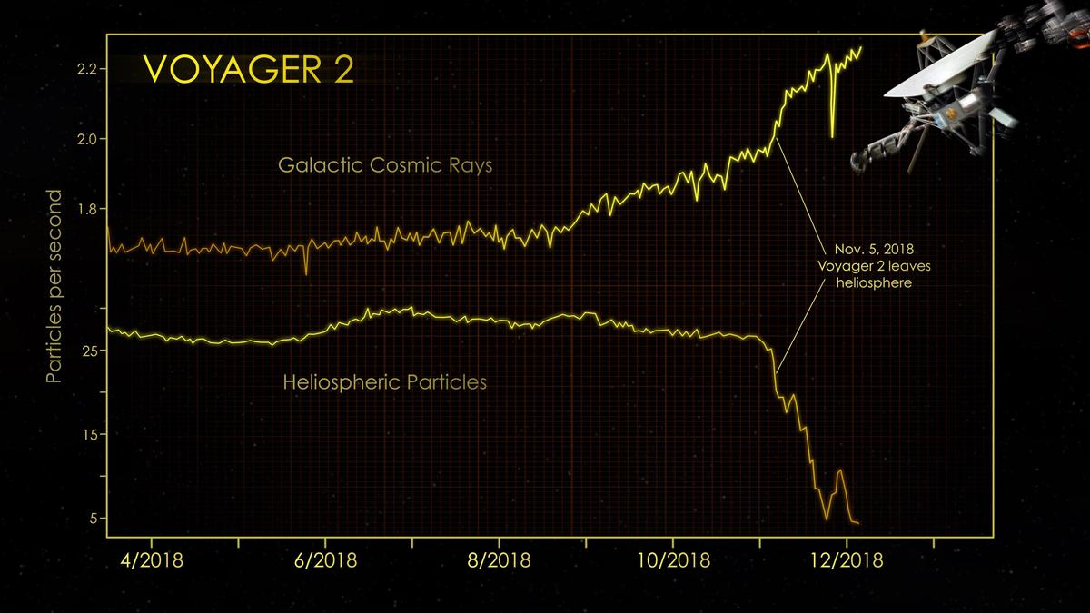  
*Voyager 2 left the heliosphere on November 5, 2018.*

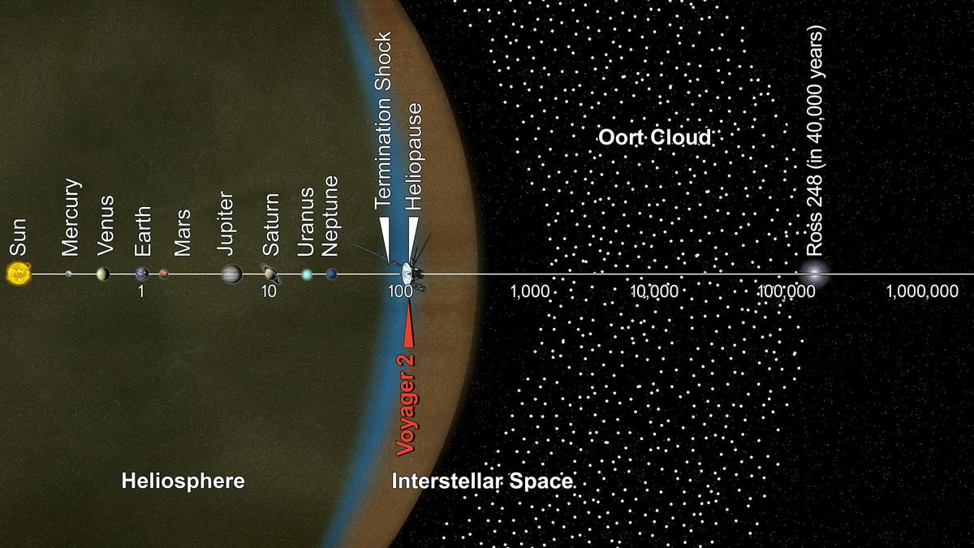  
*The current position of Voyager 2 as of December 2018. Note the vast distances condensed into an exponential scale: Earth is 1 astronomical unit (AU) from the Sun; Saturn is at 10 AU, and the heliopause is at around 120 AU. Neptune is 30.1 AU from the Sun; thus the edge of interstellar space is around four times as far from the Sun as the last planet.*

# Interstellar mission

* *Sunlight takes 13.73 hours to get to Voyager 2.*
* *In December 2018, the Voyager project scientist, Edward C. Stone, announced that Voyager 2 reached interstellar space on November 5, 2018.*
* *Information about continuing telemetry exchanges with Voyager 2 is available from Voyager Weekly Reports.*
* *(Each year Voyager 1 increases its lead over Voyager 2)*
* *Voyager 2 is heading in the direction of the constellation Telescopium.*

Once its planetary mission was over, Voyager 2 was described as working on an interstellar mission, which NASA is using to find out what the Solar System is like beyond the heliosphere. Voyager 2 is currently transmitting scientific data at about 160 bits per second. Information about continuing telemetry exchanges with Voyager 2 is available from Voyager Weekly Reports.

In 1992, Voyager 2 observed the nova V1974 Cygni in the far-ultraviolet.

In July 1994, an attempt was made to observe the impacts from fragments of the comet Comet Shoemaker–Levy 9 with Jupiter. The craft's position meant it had a direct line of sight to the impacts and observations were made in the ultraviolet and radio spectrum. Voyager 2 failed to detect anything with calculations showing that the fireballs were just below the craft's limit of detection.

On November 29, 2006, a telemetered command to Voyager 2 was incorrectly decoded by its on-board computer—in a random error—as a command to turn on the electrical heaters of the spacecraft's magnetometer. These heaters remained turned on until December 4, 2006, and during that time, there was a resulting high temperature above 130 °C (266 °F), significantly higher than the magnetometers were designed to endure, and a sensor rotated away from the correct orientation. As of this date[when?] it had not been possible to fully diagnose and correct for the damage caused to Voyager 2's magnetometer, although efforts to do so were proceeding.

On August 30, 2007, Voyager 2 passed the termination shock and then entered into the heliosheath, approximately 1 billion miles (1.6 billion km) closer to the Sun than Voyager 1 did. This is due to the interstellar magnetic field of deep space. The southern hemisphere of the Solar System's heliosphere is being pushed in.

On April 22, 2010, Voyager 2 encountered scientific data format problems. On May 17, 2010, JPL engineers revealed that a flipped bit in an on-board computer had caused the issue, and scheduled a bit reset for May 19. On May 23, 2010, Voyager 2 resumed sending science data from deep space after engineers fixed the flipped bit. Currently research is being made into marking the area of memory with the flipped bit off limits or disallowing its use. The Low-Energy Charged Particle Instrument is currently operational, and data from this instrument concerning charged particles is being transmitted to Earth. This data permits measurements of the heliosheath and termination shock. There has also been a modification to the on-board flight software to delay turning off the AP Branch 2 backup heater for one year. It was scheduled to go off February 2, 2011 (DOY 033, 2011–033).

On July 25, 2012, Voyager 2 was traveling at 15.447 km/s relative to the Sun at about 99.13 astronomical units (1.4830×1010 km) from the Sun, at −55.29° declination and 19.888 h right ascension, and also at an ecliptic latitude of −34.0 degrees, placing it in the constellation Telescopium as observed from Earth. This location places it deep in the scattered disc, and traveling outward at roughly 3.264 AU per year. It is more than twice as far from the Sun as Pluto, and far beyond the perihelion of 90377 Sedna, but not yet beyond the outer limits of the orbit of the dwarf planet Eris.

On September 9, 2012, Voyager 2 was 99.077 AU (1.48217×1010 km; 9.2098×109 mi) from the Earth and 99.504 AU (1.48856×1010 km; 9.2495×109 mi) from the Sun; and traveling at 15.436 km/s (34,530 mph) (relative to the Sun) and traveling outward at about 3.256 AU per year. Sunlight takes 13.73 hours to get to Voyager 2. The brightness of the Sun from the spacecraft is magnitude -16.7. Voyager 2 is heading in the direction of the constellation Telescopium. (To compare, Proxima Centauri, the closest star to the Sun, is about 4.2 light-years (or 2.65×105 AU) distant. Voyager 2's current relative velocity to the Sun is 15.436 km/s (55,570 km/h; 34,530 mph). This calculates as 3.254 AU per year, about 10% slower than Voyager 1. At this velocity, 81,438 years would pass before Voyager 2 reaches the nearest star, Proxima Centauri, were the spacecraft traveling in the direction of that star. (Voyager 2 will need about 19,390 years at its current velocity to travel a complete light year)

On November 7, 2012, Voyager 2 reached 100 AU from the sun, making it the third human-made object to reach 100 AU. Voyager 1 was 122 AU from the Sun, and Pioneer 10 is presumed to be at 107 AU. While Pioneer has ceased communications, both the Voyager spacecraft are performing well and are still communicating.

In 2013, Voyager 1 was escaping the Solar System at a speed of about 3.6 AU per year, while Voyager 2 was only escaping at 3.3 AU per year. (Each year Voyager 1 increases its lead over Voyager 2)

By February 25, 2019, Voyager 2 was at a distance of 120 AU (1.80×1010 km) from the Sun. There is a variation in distance from Earth caused by the Earth's revolution around the Sun relative to Voyager 2.

It was originally thought that Voyager 2 would enter interstellar space in early 2016, with its plasma spectrometer providing the first direct measurements of the density and temperature of the interstellar plasma. In December 2018, the Voyager project scientist, Edward C. Stone, announced that Voyager 2 reached interstellar space on November 5, 2018.

# Future of the probe

* *Voyager 2 is expected to keep transmitting weak radio messages until at least the mid 2020s, more than 48 years after it was launched.*
* *And if undisturbed for 296,000 years, Voyager 2 should pass by the star Sirius at a distance of 4.3 light-years.*
* *Voyager 2 is not headed toward any particular star, although in roughly 42,000 years it will pass 1.7 light-years from the star Ross 248.*

Voyager 2 is not headed toward any particular star, although in roughly 42,000 years it will pass 1.7 light-years from the star Ross 248.   
   
And if undisturbed for 296,000 years, Voyager 2 should pass by the star Sirius at a distance of 4.3 light-years. Voyager 2 is expected to keep transmitting weak radio messages until at least the mid 2020s, more than 48 years after it was launched.

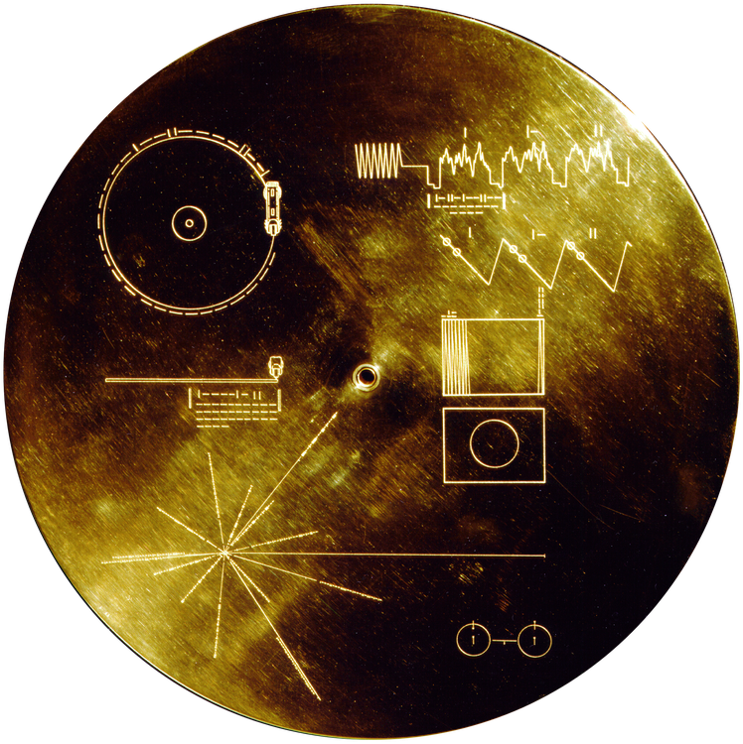  
*Voyager Golden Record*

# Golden record

* *Each Voyager space probe carries a gold-plated audio-visual disc in the event that either spacecraft is ever found by intelligent life-forms from other planetary systems.*
* *(see also Music in space)*

Each Voyager space probe carries a gold-plated audio-visual disc in the event that either spacecraft is ever found by intelligent life-forms from other planetary systems. The discs carry photos of the Earth and its lifeforms, a range of scientific information, spoken greetings from the people (e.g. the Secretary-General of the United Nations and the President of the United States, and the children of the Planet Earth) and a medley, "Sounds of Earth", that includes the sounds of whales, a baby crying, waves breaking on a shore, and a collection of music, including works by Wolfgang Amadeus Mozart, Blind Willie Johnson, Chuck Berry's "Johnny B. Goode", Valya Balkanska and other Eastern and Western classics and ethnic performers. (see also Music in space)

# See also

* *Voyager 1*

Family Portrait

List of artificial objects escaping from the Solar System

List of missions to the outer planets

New Horizons

Pioneer 10

Pioneer 11

Timeline of artificial satellites and space probes

Voyager 1

# References

# Notes

# Citations

# Further reading

* *Voyager Science Results at Saturn.*
* *Voyager Science Results at Uranus.*
* *JPL Voyager Telecom Manual*

"Saturn Science Results". Voyager Science Results at Saturn. Retrieved February 8, 2005.

"Uranus Science Results". Voyager Science Results at Uranus. Retrieved February 8, 2005.

Nardo, Don (2002). Neptune. Thomson Gale. ISBN 0-7377-1001-2

JPL Voyager Telecom Manual

# External links

* *Voyager 2 Mission Profile by NASA's Solar System Exploration*
* *Voyager 2 (NSSDC Master Catalog)*
* *NASA Voyager website*

NASA Voyager website

Voyager 2 Mission Profile by NASA's Solar System Exploration

Voyager 2 (NSSDC Master Catalog)